

**KABARAK UNIVERSITY**

**SCHOOL OF SCIENCE, ENGINEERING AND TECHNOLOGY**

**DEPARTMENT OF COMPUTER SCIENCE AND IT**

**PROJECT**

**PROJECT TITLE: PROJECT MANAGEMENT SYSTEM AND TRACKING**

Submitted on:

**AUGUST,2021**

By:

**OCHIENG V. EDWIN BBIT/MG/0798/05/17**

**A Project Report Documentation Submitted in The Department of Computer Science and IT in partial fulfillment of the degree of BBIT**.

DECLARATION

It is with honesty that I declare that this project proposal has never been offered or passed out earlier at any university that it is a work of my own. All publications and literature used have been recorded.

Name: Ochieng V. Edwin

Reg. No. Bbit/mg/0798/05/17

Sign.: ..............................

Date: 27th August 2021

**Supervised By:**

Name: Lecturer Orori Joseph

Sign: ..............................

Date: 27th August 2021

ACKNOWLEDGEMENTS

Salutes go to my academic supervisor, Lecturer Orori, for his advice and guidance for this research. And above all, all appreciation goes to God for all his work.

TABLE OF CONTENTS

DECLARATION i

ACKNOWLEDGEMENTS ii

TABLE OF CONTENTS iii

LIST OF FIGURES v

LIST OF TABLES vi

ACRONYMS vii

ABSTRACT viii

CHAPTER ONE 1

INTRODUCTION 1

1.1 Background of the Study 1

1.2 Problem Statement 1

1.3 Objectives 2

1.4 Justification 2

1.5 Significance of The Study 3

1.6 Scope 3

1.7 Research Question 3

CHAPTER TWO 4

LITERATURE REVIEWS 4

2.1. Introduction 4

2.2. Definitions 4

2.3. Project 4

2.4. Project management 6

CHAPTER THREE 9

RESEARCH METHODOLOGY 9

3.1 Introduction 9

3.2 Research Design 9

3.3 Target Population 9

3.4 Samples and Sampling Procedures 10

3.5 Instrumentation 10

3.6 Data Collection 10

3.7 Brainstorming 10

3.8 Questionnaire 10

3.9 Conducting Interviews 11

3.10 Validity and Reliability of Research Instruments 12

3.11 Context Diagram 12

3.12 Data Flow Diagram 13

3.13 E-R Diagram 16

3.14 UML Diagrams 17

3.15 Time Schedule 17

3.16 Project Cost 18

CHAPTER FOUR 19

SYSTEM DESIGN 19

4.1 Introduction 19

4.2 Logical design 19

4.3 Resources required 19

4.4 Input design 21

4.4.1. Introduction to PHP 21

4.4.2. Objectives 22

4.5 Output design 22

4.6 Relational database management system 23

**4.7** **Relationships** 23

**4.8** **Normalization** 23

4.9 Table structures 25

CHAPTER FIVE 26

SYSTEM IMPLEMENTATION AND TESTING 26

5.1 Introduction 26

5.2 Implementation procedures 27

5.3 Training on the application software 28

5.4 Operational document 28

5.5 System maintenance 28

5.6 Screenshots 29

CONCLUSION 31

RECOMMENDATION 32

REFERENCE 33

**APPENDICES** 34

**Appendix 1: Schedule** 34

**Appendix 2: Budget** 34

LIST OF FIGURES

Figure 1:Components that define a project 5

Figure 2: Monitoring and Controlling Processes 6

Figure 3:Project Management Process 7

Figure 4:Context Diagram Symbol Legend 13

Figure 5:Project Tracking System Context Diagram 13

Figure 6: Project Management System DFD 15

Figure 7:Data Flow Diagram Symbols 15

Figure 8:Client DFD 15

Figure 9:BDO DFD 15

Figure 10: PM Level 1 DFD 16

Figure 11:PM Level 2 DFD 16

Figure 12:E-R Diagram 16

Figure 13:Use Case Diagram 17

Figure 14:Relationships 17

Figure 15: client’s table 25

Figure 16: Invoices Table 25

Figure 17:Projects table 25

Figure 18:MySQL Database (Backend) 29

Figure 19:Login Page 29

Figure 20: Sign Up Page 29

Figure 21:User Dashboard 30

Figure 22:Project Page 30

Figure 23:Admin Dashboard 30

LIST OF TABLES

Table 1:Project Time Frame 34

Table 2:Project Budget Estimation 35

ACRONYMS

BDO: Block Development Officer, 15

CSS: Cascading Styling Sheet, 20

DFD: DataFlow Diagram, 13, 15, 16

GHz: Gigahertz, 19, 20

HTML: Hyper Text Markup Language, 21

IEEE: Institute of Electrical and Electronics Engineers, 33

IT: Information technology, viii

NASA: National Aeronautics and Space Administration, 8

PM: Project Manager, 15, 16, 35

PMS: Project Management System, viii

SSD: Solid State Drive, 20

UML: Unified Modelling Language, 17

ABSTRACT

As projects are important to business success and the success or failure of a project partly depends on who manages it, assigning a project to a project manager is therefore among the strategic decisions in project management. To increase an efficiency of a product, nowadays many web development companies are using different project management systems. A company may run several projects at a time, and requires input from several individuals, or teams for a multi-level development plan, whereby a good project management system is needed. PMS represent a rapidly growing technology in IT industry. As the number of users, who utilize project management applications continues to grow, web-based project management systems enter a critical role in a multitude of companies. Thus, a proper project management system plays a distinctive part in ensuring reliable, robust, and high-quality web applications for customers. Developing a web-based project management system and showing how, in turns, it helps users to handle projects. Despite its importance, literature on project manager assignment is rather limited. In practice, with the resource constraints faced by a typical organization, making appropriate assignment decisions can be challenging. This challenge is even more paramount in a setting where project managers lead multiple, concurrent projects. Strategically speaking, management should assign projects to project managers in such a way that the assignments enhance the accomplishment of the organization’s strategic objectives. For this to be achieved the right tools need to be delivered for optimal performance and maximum productivity. This project goes ahead through the depths of delivering the required tools to aid in accomplishing and making real this goal. The goal of this app is to help users track and manage their time spent doing different activities. Additionally, users can share their time schedules with others. The first chapter dives into the description of the drivers that are causing development of the system. Looking into forms such as the background of the study, problem statement, objective, justification, significance of the study, scope and finalizing with the research questions. The following chapter two, literature review reflects emphasis on the basic and foundational information that would help in completion and understanding of this proposal. The third chapter is the research methodology which defines strategies conducted while sources for information dependent and driving the defense and success of this proposal. At the tail end is an inclusion of references and appendix depicting the credibility and validity of information presented during the whole project process.

CHAPTER ONE

INTRODUCTION

1. Background of the Study

The prime function of a project management system is to assist managers with their everyday project management responsibilities. Summarizing the modern project management system, you can consider it as an assembly of tools that help you to accomplish various activities within project management.

1. Existing System

The current monitoring system is ineffective and inefficient in providing adequate and reliable information to users.

1. Description of the current system

Existing system of system of project management is manual. Project coordinator or guide gives task for student manually. Staff complete the work which is given by coordinator or guide and submits manually, in this system all work is done by manually so it can take more time to complete project related work.

1. Disadvantages of the existing system

It is time consuming. Right information is not retrieved at right time. Any updates to the data by team members or the Project coordinator or guide cannot see immediately by the rest of the team. All work is done manually.

1. Problem Statement

Project managers struggle to keep teams on the same page when it comes to coordination of everyone’s prospects. The fact that everyone gets engaged with their own portions with such certainty because it is their sole responsibility. Project teams face challenges when it comes to defining of targets and objectives. The teams lack sequential, structured and a more directed approach when it gets to setting out the objectives and goals. Working on projects without restricted time frames becomes a challenge for project success.

Enforcing deadlines becomes a challenge basing on how each individual or team is designated its own task to perform. Lack of accountability when it comes to how the project stages and results get coordinated. Upon submission of a dependent aspect of a problem. Lack of an adequate and effective mode of communication hinders the way the project will be undertaken. Currently, the primary method of communication would be through emails, physical meeting or sending of documents which have their own disadvantages hindering the speedy and effective completion of a project.

1. Objectives
2. Main Objective

The primary objective of undertaking creates a centralized and modern mode of implementing the rewards of information technology onto the project management and development process.

1. Specific Objective
2. To analyze the project management and tracking system.
3. To design the improved project management and tracking system.
4. To evaluate the resources and information required for the development of the proposed system.
5. To evaluate the performance of the system; checking whether it serves the purpose for development.
6. To create a simplified mode of individual and team collaboration.
7. To promote and enhance the process of decision making.
8. To improve the system in which local and remote communication is conducted.
9. To enable easier tracking and monitoring of project stages and processes.
10. To control and structure scheduling and time management.
11. To effectively coordinate task completion.
12. Justification

Establishing of a project management and tracking app would mean making real and taking advantage of the technology of cloud-based solutions. Organizations would not worry about having to rely on a physical location to access and retrieve project materials and resources.

Further, it would mean that workflows would be made available seamlessly with teams or individuals working productively regardless of locational barriers. The proposed app would aid in easier planning and allocation of time that suites the scope of a given time.

This goes ahead to do away with project stages that are lengthy for no good reason and that would mean even more productivity.

The proposed app would ensure teams are able to access material and work independently of their locational and physical barriers with the ability to work and collaborate anywhere. This kind of internal and external communication would deliver better comprehension and understanding of the project goals.

1. Significance of The Study

The major advantage that the proposed app would bring will be to digitized and simplify the process of managing and tracking the stages of a project for any specified organization. This would be through efficient task delegation, better file and info access, enhanced productivity as well as risk mitigation.

1. Scope

The proposed app provides a first-time startup wizard upon installation that would guide its users while describing its features. Afterwards, it would proceed to a Realtime dashboard which would be made available suiting the needs of project managers, staff, or teams as well as support even for a client(viewer). The proposed app would also feature templates selectable from the dashboard for performing tasks and procedures in a simple and single instance.

It would further give project managers the functionality of creating projects and tasks which base on criteria such as deadlines, and level of expertise or specialization. The proposed system would also feature a means for contact management for users, giving them the ability to access and append info on a message board, receive notifications for messages from other users, as well as having different access level and privileges.

1. Research Question
2. How can the proposed app create a value means for sharing and benefiting from the information outcome?
3. How can the proposed app give project managers better integration and procurement?
4. What ways the app will foster a form of project leadership and structure?
5. How the proposed app would save on costing and time resources to deliver the best productivity with minimal consumption of resources?
6. What are the requirements of a project management software?
7. Does the selected software fulfill the requirements?

CHAPTER TWO

LITERATURE REVIEWS

1. Introduction

In this section, related literature is reviewed to help in the analysis, design and development of a prototype web-based project tracking system. A Project is a series of routine steps to perform a particular function. A program can be a set of goals that give rise to specific projects but unlike a project, a project can never be completely accomplished.

1. Definitions

**Project** – A temporary endeavor undertaken to create a unique product or service; a set of interrelated activities organized to achieve a specific goal; the process of moving from a problem to a solution using a plan.

**Project Charter** – A document used to confirm agreement and obtain commitment from all affected parties associated with a specific project. It provides an overview and lays the foundation for the project structure and how the project will be managed. Project Charters typically include a high-level Project/Problem Description, Objective, Scope Definition, Deliverables, Acceptance Criteria, Assumptions, Constraints/Dependencies, Roles and Responsibilities, Risks, Milestones, Estimated Benefits and Costs, Project Sponsor, and Team.

**Project Management** – The application of knowledge, skills, tools, and techniques to project activities to meet or exceed the stakeholder needs and expectations of the project. (ICTer & IEEE, 2014)

1. Project

Projects Tracking System is done with the following roles; team member, team leader,

and the supervisor of the project who review and control team works. During each phase, team leader will be responsible for coordinating team meetings, updates, and review team deliverables. (McManus & Wood-harper, 2003)

**Components that define a project include:**

* Specific scope: the desired results or products
* Schedule: established dates when project work starts and ends
* Required resources: Necessary number of people, funds and other resources.

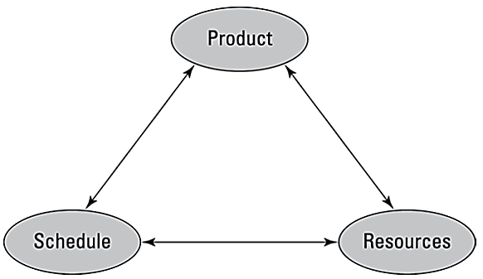

Figure 1:Components that define a project

**Diversity of Projects**

* Large/small
* Many people/single person
* Defined by legal contract/ informal agreement
* Business related/personal

**Phases of Project Life Cycle**

* Starting the project: involves generating, evaluating, and framing the business need for the project and the general approach to performing it and agreeing to prepare a detailed project plan. Outputs from this phase may include approval to proceed to the next phase, documentation of the need for the project and rough estimates of time and resources to perform it (often included in a project charter), and an initial list of people who may be interested in, involved with, or affected by the project.
* Organizing and preparing: This phase involves developing a plan that specifies the desired results; the work to do; the time, cost, and other resources required; and a plan for how to address key project risks. Outputs from this phase may include a project plan that documents the intended project results and the time, resources, and supporting processes needed to create them.
* Carrying out the work: This phase involves establishing the project team and the project support systems, performing the planned work, and monitoring and controlling performance to ensure adherence to the current plan. Outputs from this phase may include project results, project progress reports, and other communications.
* Closing the project: This phase involves assessing the project results, obtaining customer approvals, transitioning project team members to new assignments, closing financial accounts, and conducting a post-project evaluation. Outputs from this phase may include final, accepted, and approved project results and recommendations and suggestions for applying lessons learned from this project to similar efforts in the future

1. Project management

Project management is the process of guiding a project from its beginning through its performance to its closure. (Bob & Mike, 2002)

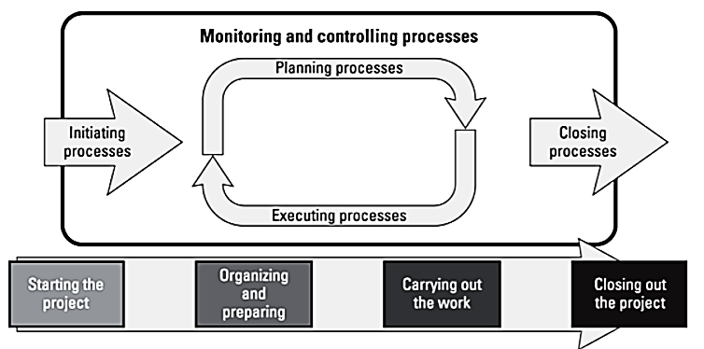

Figure 2: Monitoring and Controlling Processes

1. Project Stakeholders

**Internal:**

People and groups inside your organization Upper management: Executive-level management responsible for the general oversight of all organization operations Requesters: The person who came up with the idea for your project and all the people through whom the request passed before you received it Project manager: The person with overall responsibility for successfully completing the project End users: People who will use the goods or services the project will produce Team members:

**External:**

People and groups outside your organization Clients or customers: People or groups that buy or use your organization’s products or services Collaborators: Groups or organizations with whom you may pursue joint ventures related to your project Vendors, suppliers, and contractors: Organizations that provide personnel, raw materials, equipment, or other resources required to perform your project’s work Regulators:

1. Project Management Process Overview

Project management is the process of developing substantive, systematic data about each parameter in order to maximize the effectiveness of the tradeoff decision. The project management process is itself a series of steps typically represented by a “project management process model.”

The model used for project management, depicted in Figure A, consists of three global sets of activities (Define and Organize, Plan, and Track and Manage). Within these sets of global activities are the specific steps for defining, planning, and managing the project.

1. **Define and Organize the Project** The success of a project is usually determined by the clarity of its objectives and how well team members coordinate project activities. We assume, therefore, that to effectively complete a project we need to know the objectives, the people who will work as a team to achieve them, and the manner in which they will be carried out. An astounding proportion of projects fail because the desired outcome is poorly defined and the organization and procedures to accomplish it are ill understood.
2. **Plan the Projec**t A source of considerable conflict in nearly every project is the tension between the time frame established for completing the project and the risks involved in compressing it. A credible project plan takes account of both the demands of managers outside the project team for as aggressive a schedule as possible and the awareness of those on the project team of the difficulties of the task at hand. A credible project plan based on a reliable, systematic process enables senior managers to understand and trust the schedule and make better management decisions about project tradeoffs.
3. **Track and Manage the Project**

“Managing the plan” seems a simple enough notion, yet too often as soon as the plan is done (if a plan is done) project management typically ceases as the impulse to “get the work done” takes over. As the project gains momentum, team members find it easier to work on discrete tasks that produce tangible results than to manage an intangible process. But by not tracking the project, both project manager and team miss the opportunity to collect critical project data and take timely actions that will be crucial to success.

This is possible because tracking provides specific data to support focused, discrete interventions. (PDEVM, 2017)

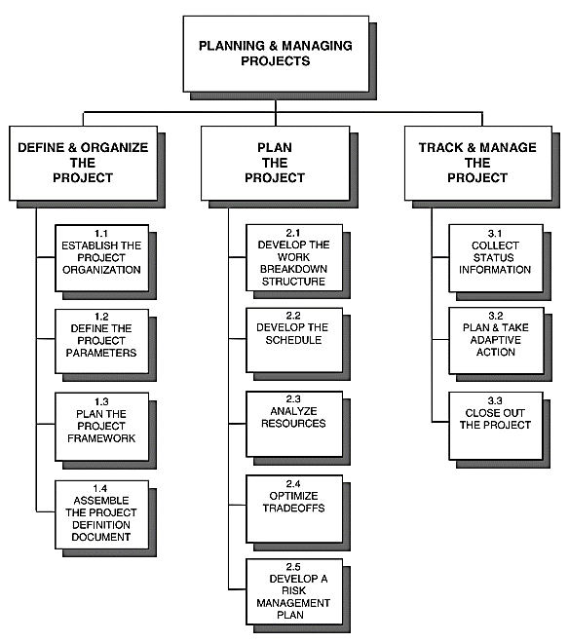

Figure 3:Project Management Process

1. History of Project Management

Project Management has been practiced ever since, thousands of years ago since the Egyptian era, although, it has been just few decades back since the organizations have started to use this idea of project management in a systematic way. In the past, the principles of project management have been used by the large engineering and construction companies to manage large budget, schedule driven projects. Organizations like NASA and Department of Defense started using those principles since the 1960s. While it was only in 1980 when the manufacturing and software development sectors started to adopt and implement the project management practices. By the 1990s, the project management theories, tools and techniques were widely received by different industries and organizations. (Kieron, 2001)

CHAPTER THREE

RESEARCH METHODOLOGY

1. Introduction

This chapter entails the description of the selected research design, structure and strategy of investigation that was adopted to obtain answers to research questions to control variance. In order to achieve any meaningful solution to a practical or theoretical problem in any field of study, the research process needs to be conducted cautiously.

This includes target population, sample procedures, data collection instruments, validity and reliability of the research instrument and data presentation. The following features of the current system were studied.

* Technologies used - what techniques are used to monitor progress reports. It was established that manual system of reporting is used to transmit data from constituencies to the headquarters.
* Procedures- What procedures are used to collect and disseminate the data/information.
* Processes- what processes are involved in project monitoring.
* Inputs- what are the data inputs into the system.
* Outputs- what information is required from the system.
* Security- what security measures are required to secure the system.

During data gathering, the population to be used during the investigation was determined. The sample of population to use was designed, the data collected and finally analyzed.

1. Research Design

The researcher used descriptive research design for the study. The use of a descriptive research design was appropriate since it led to a better understanding of those being studied. The study minimized the limitations of descriptive design by ensuring that the data collection tools were well designed and established to minimize their errors. The study aimed at describing the kind of effects, informs of overall performance of insurance companies and the effects it has on its performance. (Shelly, 1991)

1. Target Population

Population as the aggregation of elements from which sample is actually selected or the theoretical specification of the universe. The samples of the study are thus drawn from the population but the results-of the study will apply to the whole population. The IT group was selected since they are involved with activities of the infrastructure to support the proposed system and thus have pertinent information regarding the current data entry procedures on field report data and suggestions for the alternative system. Members of the Board and Committee are involved with policy formulation and enforcement and involving them in integrating this in the system was imperative.

1. Samples and Sampling Procedures

Sampling as the process of systematically selecting reprehensive elements of the population. When selected elements are examined closely, it is assumed their analysis will reveal useful information about the population. They add sampling has four advantages:

* It helps accelerate the process of gathering and analyzing data rather than for entire population.
* It helps in following up missing or incomplete data thus helps in improving effectiveness.
* It helps in containing costs.
* Helps in reducing bias.

1. Sampling Procedures
2. Instrumentation

The study aimed at using secondary data and a set of technology information set at helping the insurance companies in setting their proposed insurance fees for individual who will want to insure their properties and how much they should pay for the fees depending on their targeted location.

1. Data Collection

A process of gathering pertinent information about a phenomenon under study. The forms of data collection techniques are:

* Brainstorming
* Questionnaires

This project will employ survey research and secondary data analysis.

1. Brainstorming

When objectives are stated clearly and understood by the participants, a brainstorming session drawing on the creativity of the participants can be used to generate a list of routines.

In a well facilitated brainstorming session, the participants are collaborators, comprising a team that works together to articulate the risks that may be known by some in the group.

1. Questionnaire

A technique that allows one to study the attitudes, beliefs, behavior and characteristics of several people in an organization who may be affected by current system or proposed system.

1. Semi structured interview questions

Participant’s name: _________________________

Position: ____________________

Software: ____________________

Questions:

1. How did you learn the software?
2. How long did you take to learn this software?
3. How do you get in/log in in the software? / What do you require to get into the software?
4. How simple is it for you to access to all the projects after logging in?
5. How often do you use the software in a day? / Please tell me the situations where the software must be used.
6. Do you track the project progress?
7. How often? And for what purpose do you track the project?
8. Is it possible to track another project than your own?
9. How do you communicate with other people working in the same project (via the software)? [may be Forum]
10. How about people working in different projects? Or Project Manager?
11. How do you usually contact with other people within your project and other projects?
12. Are you able to tag people in so that they get noticed? - If yes, where do you get the notifications?
13. What is the role of project manager in the context of this software?
14. How many people in average work in a single project?
15. How long does it take to finish a project? In average if you could tell?
16. What is the final step when the project finishes? (in the context of the software)
17. Can people do/manage multiple projects at the same time?60
18. Conducting Interviews

During the interview, I was able to get the opinions of the interviewees and their feelings about current state of project tracking systems, organizational goals and informal procedures. The interview helped to get relevant data and allowed for spontaneity.

1. Step 1: Select the Interview

The first step is to select the right person to interview. There are three characteristics that you should look for when selecting an interviewee.

One characteristic that your potential interviewee should possess is a high degree of skill in, or knowledge of, a certain subject. Experts with a high level of skill or knowledge will be able to identify specific project risks, such as financial or technical risks.

1. Step 2: Prepare the Interview

The second step in the interviewing process is to prepare the interviewee for questioning. At this stage, you should tell the interviewee what the project goals are, how long the project is expected to last, and what the constraints facing the project are.

Each selected interviewee will also need specific information that can be found in the project definition, scope documentation, and in the project's high-level

For example, a project manager informs several interviewees that the project under examination involves the development of a new kind of pain reliever. This project is expected to be delivered within one year of the start date and have less than a four-percent probability of harmful side effects. In addition, the project is faced with a limited number of contingency reserves and may encounter budget problems if any of the critical path phases are delayed.

1. Step 3: Direct the Interview

The third step of the interviewing technique is to direct the interview. As a project manager, it is your responsibility to ensure that your interview stays on track. You must use the experience and knowledge of your expert, combined with all relevant project information, to identify as many project risks as possible.

1. Validity and Reliability of Research Instruments

Validity is the degree to which results from the analysis of the data represent the phenomenon under study.

It has to do with how accurately the data obtained represented the variable under study.

Reliability is the measure of the degree to which the research instruments yield consistent results or data after repeated results.

1. Context Diagram

The context diagram is a data flow diagram showing data flows between a generalized application within the domain and the other entities & abstractions with which it communicates. One thing that differentiates the use of data flow diagrams in domain analysis from other typical users is that the variability of the data flows across the domain boundary must be accounted for with either a set of diagrams or text describing the differences. (William, 2005)

Context DFD is for the projects tracking system which consist of three main roles. Each of them has different inputs and outputs. First, the system itself is processes which receives the inputs and transform the outputs from the external entities which are: client, employee, manager.

The client will sign up to the system by filling the register form. After that he can request for project. Then the manager will decide whether to accept or reject the project. In case of accepting the project, an automatic email sent to the client. After that the client must pay for the project. Furthermore, the manager will assign the tasks for the employee along with due date for submission. Then, the employee will perform and submit the task according to the due date specified by the manager. The manager may perform other functions as shown in the diagram

**System**

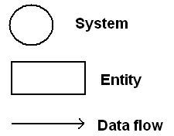

Figure 4:Context Diagram Symbol Legend

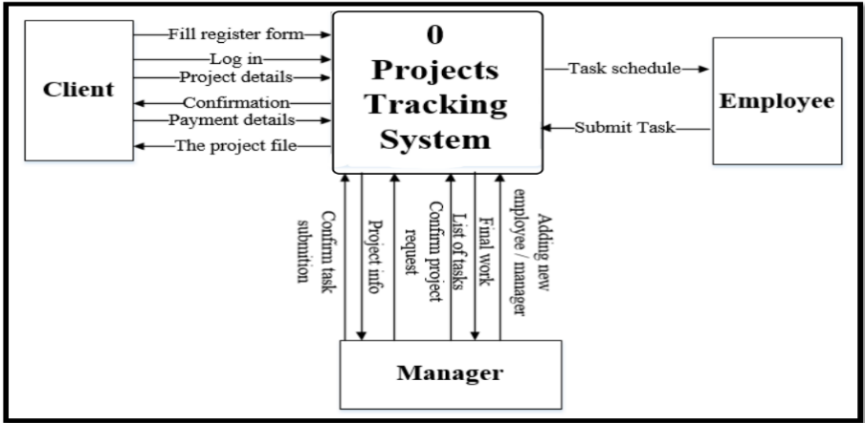

Figure 5:Project Tracking System Context Diagram

1. Data Flow Diagram

DFD’s represents the flow of data. data flow diagram (DFD) that describe the work and processing performed by the system with all of its components and subcomponents. DFD will describe all of the inputs and outputs that had explained context DFD

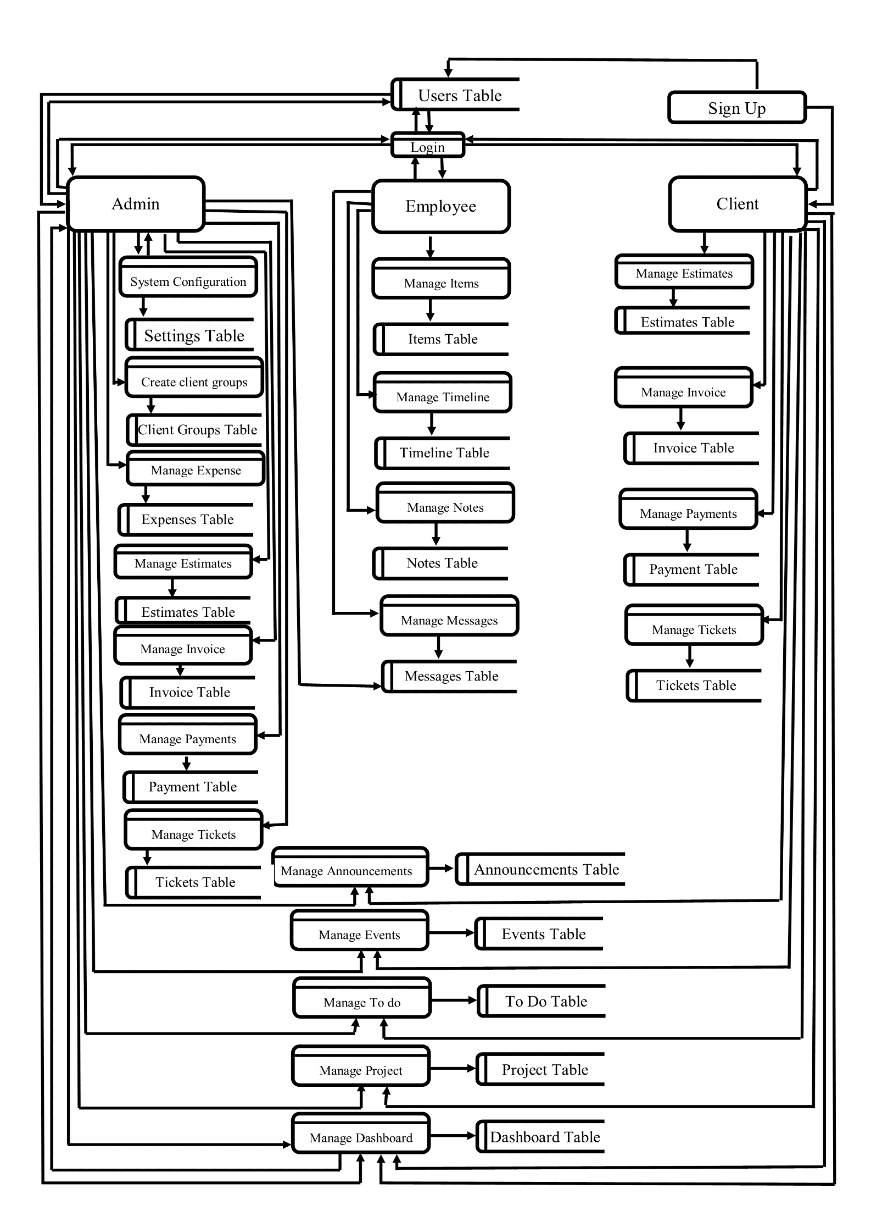

Figure 6: Project Management System DFD

The symbols that we use are:

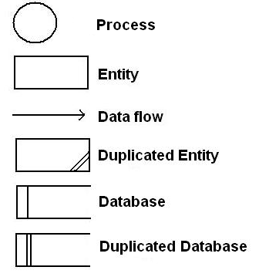

Figure 7:Data Flow Diagram Symbols

**Client DFD**

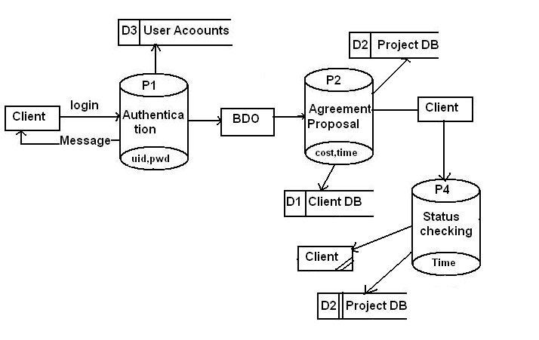

Figure 8:Client DFD

**BDO DFD**

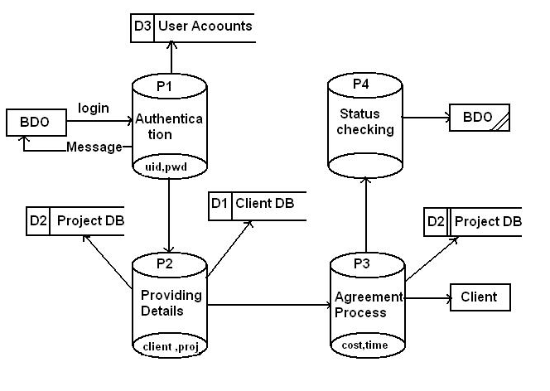

Figure 9:BDO DFD

**PM Level 1 DFD**

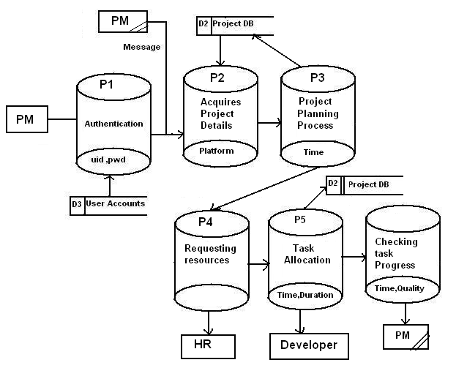

Figure 10: PM Level 1 DFD

**PM Level 2 DFD**

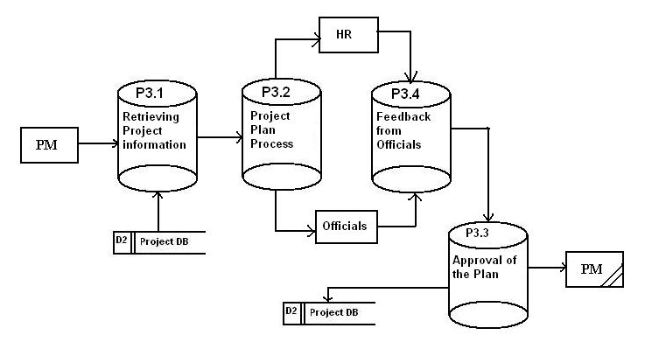

Figure 11:PM Level 2 DFD

1. E-R Diagram

The following diagram depicts various entities involved in the Project Tracking System and relationships between those entities.

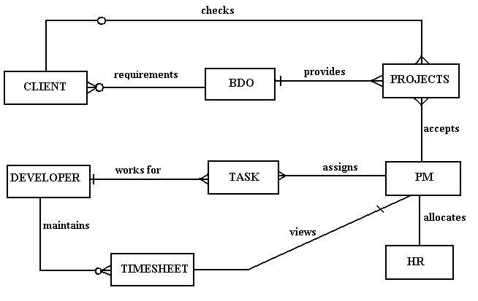

Figure 12:E-R Diagram

1. UML Diagrams
2. Use Case diagram

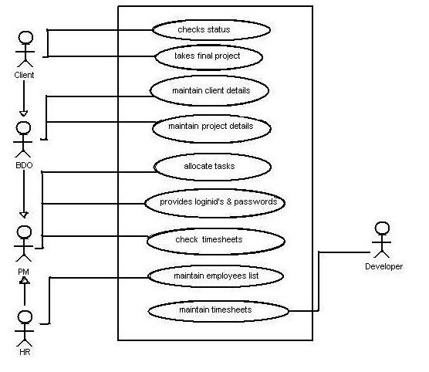

Figure 13:Use Case Diagram

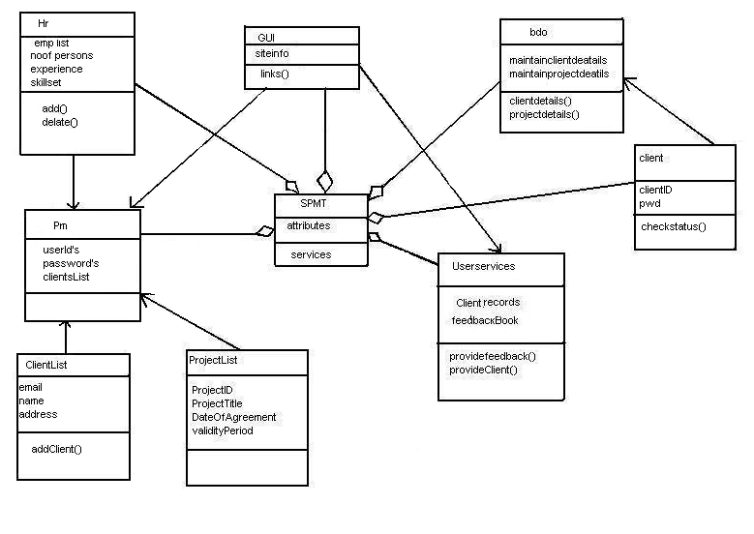

Figure 14:Relationships

1. Time Schedule

The definition of project success often includes completing the project on time. The development and management of a project schedule that will complete the project on time is a primary responsibility of the project manager, and completing the project on time requires the development of a realistic plan and the effective management of the plan.

On smaller projects, project managers may lead the development of the project plan and build a schedule to meet that plan. On larger and more complex projects, a project controls team that focuses on both costs and schedule planning and controlling functions will assist the project management team in developing the plan and tracking progress against the plan.

1. Project Cost

definition of project success often includes completing the project within budget. Developing and controlling a project budget that will accomplish the project objectives is a critical project management skill. Although clients expect the project to be executed efficiently, cost pressures vary on projects. On some projects, the project completion or end date is the largest contributor to the project complexity. The development of a new drug to address a critical health issue, the production of a new product that will generate critical cash flow for a company and the competitive advantage for a company to be first in the marketplace with a new technology are examples of projects with schedule pressures that override project costs.

CHAPTER FOUR

SYSTEM DESIGN

1. Introduction

Design is the first step into the development phase for any engineered product or system. Design is a creative process. A good design is the key to effective system. The term “design” is defined as “the process of applying various techniques and principles for the purpose of defining a process or a system in sufficient detail to permit its physical realization”. It may be defined as a process of applying various techniques and principles for the purpose of defining a device, a process, or a system in sufficient detail to permit its physical realization. Software design sits at the technical kernel of the software engineering process and is applied regardless of the development paradigm that is used. The system design develops the architectural detail required to build a system or product. As in the case of any systematic approach, this software too has undergone the best possible design phase fine tuning all efficiency, performance, and accuracy levels. The design phase is a transition from a user-oriented document to a document to the programmers or database personnel. System design goes through two phases of development: Logical and Physical Design.

1. Logical design

The logical flow of a system and define the boundaries of a system. It includes the following steps:

* Reviews the current physical system – its data flows, file content, volumes, Frequencies etc.
* Prepares output specifications – that is, determines the format, content, and Frequency of reports.
* Prepares input specifications – format, content, and most of the input functions.
* Prepares edit, security, and control specifications.
* Specifies the implementation plan.
* Prepares a logical design walk through of the information flow, output, input, Controls, and implementation plan.
* Reviews benefits, costs, target dates and system constraints.

1. Resources required

#### 4.3.1 Hardware resources

1. A Personal Computer with the following specifications.

(Minimum)

* RAM 8 Gigabytes.
* Intel Quad Core i5 7th Generation Processor speed 3.0 GHz and Above.
* Graphics Card: 1GB Nvidia or AMD Ryzen.
* Hard disk capacity 1 TB
* 4 24” Monitors 1080p Full HD Display

(Recommended)

* RAM 16 GB.
* Intel Quad Core i7 11th Generation Processor speed 5.0 GHz and Above.
* Graphics Card: 2GB Nvidia or AMD Ryzen.
* Hard disk capacity 2 TB
* NVMe 256GB SSD
* 4 32” Monitors 4K Ultra HD Display

1. Laser Printer.
2. Fast Internet Access.
3. UPS.

#### 4.3.2 Software resources.

1. Operating system: Windows 10
2. Document viewer: Microsoft Word.
3. Database Management system: MYSQL.
4. Antivirus: Kaspersky
5. Web Browser: Chrome
6. Development Languages: Back-end (Php, JavaScript.) Front-end (Html, CSS,)
7. Integrated Development Environment (IDE): Visual Studio Code
8. Web Server: Apache

#### 4.3.3 Functional Requirements

1. The system will capture bio data and other information about any person with a case and store them in a database.
2. The system will only authorize specific personnel who are responsible for taking the data using an authentication login.
3. The system will be able to search persons by national ID number provided to the system and display a report.
4. The system will be able to delete any unwanted records from the database and update accordingly.
5. The system will be able to give desired reports according to the user request.

#### Non-Functional Requirements

These are requirements that define system characteristics or attributes. They describe how a system should behave and what limits are there on its functionality. The proposed system has been developed using MYSQL which provides a database management system as well as a test server to be able to test how data is going to interact with the users once they have been captured in the database.

**Security:** The system ensures the security of its user’s credentials. The system has several security features to protect user’s credentials at various levels such as:

Database Level: The database is password protected. Passwords are encrypted.

Application Level: Every user has credentials only known to them. To access the system, the users must log in. Changes done to a reported crime are stored for tracking due to sensitivity of the case, and they must be known. Deployment Level: The system runs on Java platform which is very secure.

**Response Time:** Response time concerning user requests should be within 1 to 3 seconds.

Throughput: The system allows many users to access it concurrently.

Reliability: The system is 99% operational.

Accuracy: The system present accurate data to the users to maintain its credibility and that of the users as well.

Access Reliability: The system is accessible 99% of the time.

1. Input design
2. Introduction to PHP

**What is php*?***

PHP stands for **P**HP: **H**ypertext **P**reprocessor. PHP is a server-side scripting language, like ASP. PHP supports many databases (MySQL, Informix, Oracle, Sybase, Solid, PostgreSQL, Generic ODBC, etc.) PHP is an open-source software. PHP is free to download and use.

**Some of the main features of PHP are listed below:**

that page. The PHP module executes the script, which then sends out the result in the form

of HTML back to your browser, which you see on the screen. Here is a basic

php diagram which illustrate the process. PHP runs on different platforms (Windows, Linux, Unix, etc.) PHP is compatible with almost all servers used today (Apache, IIS, etc.) PHP is FREE to download from the official PHP resource .PHP Is easy to learn and runs efficiently on the server side

**Introduction to PHP**:

PHP sits between your browser and the web server. When you type in the URL of a PHP website in your browser, your browser sends out a request to the web server. The web server then calls the PHP script on PHP is a server-side, cross-platform, HTML-embedded scripting language. There are over half a million domains running PHP and it is freely available for download. Much of PHP’s syntax is borrowed from C, Java, and Perl with a couple of unique PHP-specific features thrown in. The goal of the language is to allow web developers to write dynamically generated pages quickly. PHP eliminates the need for numerous small CGI programs by allowing you to place simple scripts directly in your HTML files.

It also makes it easier to manage large web sites by placing all components of a web page in a single html file. PHP is an excellent alternative to such similar programming solutions as Microsoft’s proprietary scripting engine ASP and Allaire's rather expensive ColdFusion

The input is designed in such a way so that it provides security and ease of use with retaining the privacy. Input Design considered the following things:

* What data should be given as input?
* How the data should be arranged or coded?
* The dialog to guide the operating personnel in providing input.
* Methods for preparing input validations and steps to follow when error occur.

1. Objectives

* Input Design is the process of converting a user-oriented description of the input into a computer-based system. This design is important to avoid errors in the data input process and show the correct direction to the management for getting correct information from the computerized system.
* It is achieved by creating user-friendly screens for the data entry to handle large volume of data. The goal of designing input is to make data entry easier and to be free from errors. The data entry screen is designed in such a way that all the data manipulates can be performed. It also provides record viewing facilities.
* When the data is entered it will check for its validity. Data can be entered with the help of screens. Appropriate messages are provided as when needed so that the user will not be in maize of instant. Thus, the objective of input design is to create an input layout that is easy to follow

1. Output design

A quality output is one, which meets the requirements of the end user and presents the information clearly. In any system results of processing are communicated to the users and to other system through outputs. In output design it is determined how the information is to be displaced for immediate need and the hard copy output. It is the most important and direct source information to the user. Efficient and intelligent output design improves the system’s relationship to help user decision-making.

* Designing computer output should proceed in an organized, well thought out manner; the right output must be developed while ensuring that each output element is designed so that people will find the system can use easily and effectively. When analysis design computer output, they should Identify the specific output that is needed to meet the requirements.
* Select methods for presenting information.
* Create document, report, or other formats that contain information produced by the system.

The output form of an information system should accomplish one or more of the following objectives.

* Convey information about past activities, current status, or projections of the Future.
* Signal important events, opportunities, problems, or warnings.
* Trigger an action.
* Confirm an action.

1. Relational database management system

A relational model represents the database as a collection of relations. Each relation resembles a table of values or file of records. In formal relational model terminology, a row is called a tuple, a column header is called an attribute and the table is called a relation. A relational database consists of a collection of tables, each of which is assigned a unique name. A row in a tale represents a set of related values.

**Relations, Domains & Attributes:**

A table is a relation. The rows in a table are called tuples. A tuple is an ordered set of n elements. Columns are referred to as attributes. Relationships have been set between every table in the database. This ensures both Referential and Entity Relationship Integrity. A domain D is a set of atomic values. A common method of specifying a domain is to specify a data type from which the data values forming the domain are drawn. It is also useful to specify a name for the domain to help in interpreting its values. Every value in a relation is atomic, that is not decomposable.

### **Relationships**

* Table relationships are established using Key. The two main keys of prime importance are Primary Key & Foreign Key. Entity Integrity and Referential Integrity Relationships can be established with these keys.
* Entity Integrity enforces that no Primary Key can have null values.
* Referential Integrity enforces that no Primary Key can have null values.
* Referential Integrity for each distinct Foreign Key value, there must exist a matching Primary Key value in the same domain. Other key is Super Key and Candidate Keys.
* Relationships have been set between every table in the database. This ensures both Referential and Entity Relationship Integrity.

### **Normalization**

As the name implies, it denoted putting things in the normal form. The application developer via normalization tries to achieve a sensible organization of data into proper tables and columns and where names can be easily correlated to the data by the user. Normalization eliminates repeating groups at data and thereby avoids data redundancy which proves to be a great burden on the computer resources. These includes:

* Normalize the data.
* Choose proper names for the tables and columns.
* Choose the proper name for the data.

1. **First Normal Form:**

The First Normal Form states that the domain of an attribute must include only atomic values and that the value of any attribute in a tuple must be a single value from the domain of that attribute. In other words, 1NF disallows “relations within relations” or “relations as attribute values within tuples”. The only attribute values permitted by 1NF are single atomic or indivisible values.

The first step is to put the data into First Normal Form. This can be donor by moving data into separate tables where the data is of similar type in each table. Each table is given a Primary Key or Foreign Key as per requirement of the project. In this we form new relations for each nonatomic attribute or nested relation. This eliminated repeating groups of data.

A relation is said to be in first normal form if only if it satisfies the constraints that contain the primary key only.

1. **Second Normal Form:**

According to Second Normal Form, for relations where primary key contains multiple attributes, no non key attribute should be functionally dependent on a part of the primary key.

In this we decompose and setup a new relation for each partial key with its dependent attributes. Make sure to keep a relation with the original primary key and any attributes that are fully functionally dependent on it. This step helps in taking out data that is only dependent on a part of the key. A relation is said to be in second normal form if and only if it satisfies all the first normal form conditions for the primary key and every non-primary key attribute of the relation is fully dependent on its primary key alone.

1. **Third Normal Form:**

According to Third Normal Form, Relation should not have a monkey attribute functionally determined by another nonkey attribute or by a set of nonkey attributes. That is, there should be no transitive dependency on the primary key.

In this we decompose and set up relation that includes the nonkey attributes that functionally determines other nonkey attributes. This step is taken to get rid of anything that does not depend entirely on the Primary Key.

A relation is said to be in third normal form if only if it is in second normal form and more over the non key attributes of the relation should not be depend on another non-key attribute.

1. Table structures

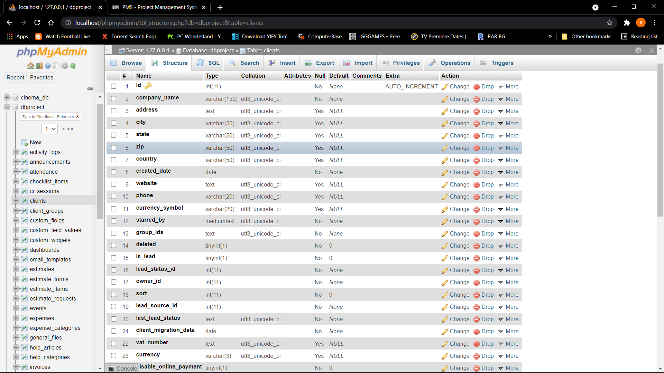

Figure : client’s table

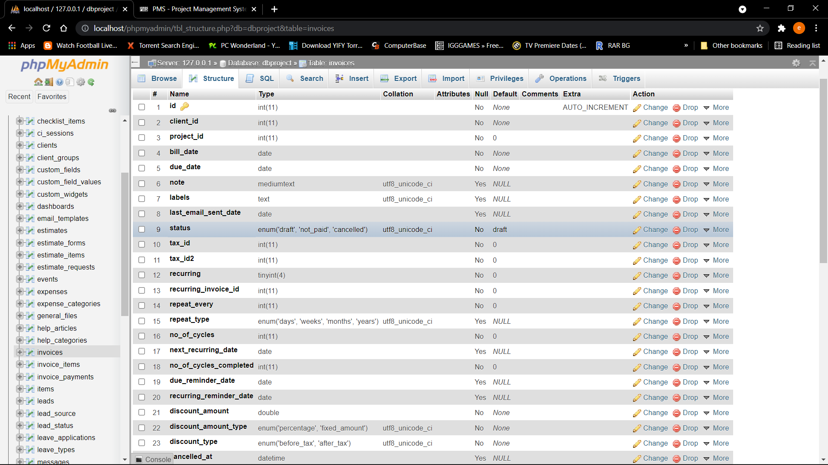

Figure : Invoices Table

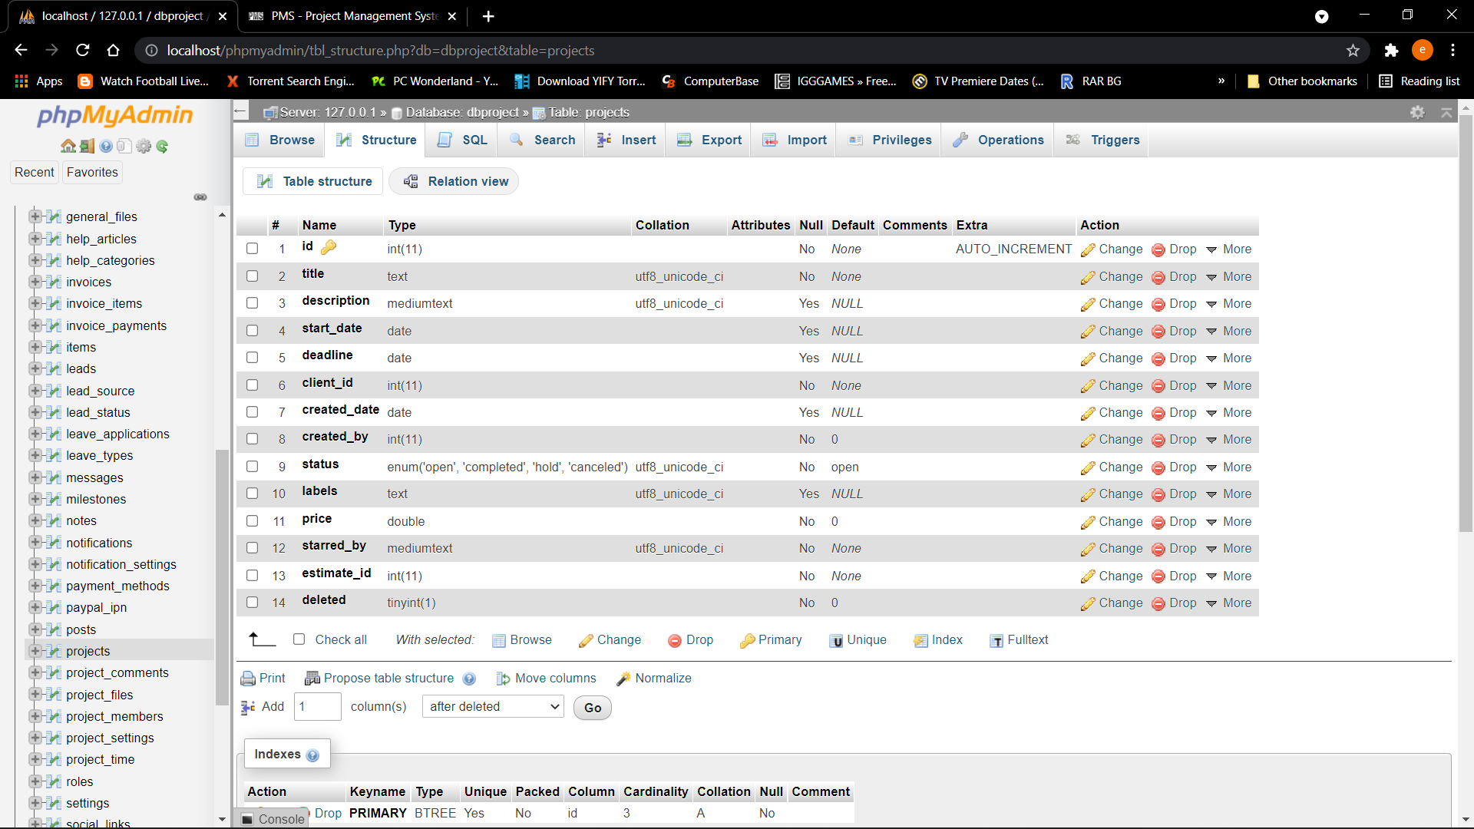

Figure :Projects table

CHAPTER FIVE

SYSTEM IMPLEMENTATION AND TESTING

1. Introduction

Software Testing is the process of executing software in a controlled manner, to answer the question - Does the software behave as specified? Software testing is often used in association with the term’s verification and validation. Validation is the checking or testing of items, includes software, for conformance and consistency with an associated specification. Software testing is just one kind of verification, which also uses techniques such as reviews, analysis, inspections, and walkthroughs. Validation is the process of checking that what has been specified is what the user wanted.

Validation **:** Are we doing the right job?

Verification **:** Are we doing the job right?

Software testing should not be confused with debugging. Debugging is the process of analyzing and localizing bugs when software does not behave as expected. Although the identification of some bugs will be obvious from playing with the software, a methodical approach to software testing is a much more thorough means for identifying bugs. Debugging is therefore an activity which supports testing, but cannot replace testing.

Other activities which are often associated with software testing are static analysis and dynamic analysis. Static analysis investigates the source code of software, looking for problems and gathering metrics without executing the code. Dynamic analysis

looks at the behavior of software while it is executing, to provide information such as execution traces, timing profiles, and test coverage information.

Testing is a set of activity that can be planned in advanced and conducted systematically. Testing begins at the module level and work towards the integration of entire computers-based system. Nothing is complete without testing, as its vital success of the system testing objectives, there are several rules that can serve as testing objectives. They are

* Testing is a process of executing a program with the intend of finding an error.
* A good test case is one that has high possibility of finding an undiscovered error.
* A successful test is one that uncovers an undiscovered error.

If a testing is conducted successfully according to the objectives as stated above, it would have uncovered errors in the software also testing demonstrate that the software function appears to be working according to the specification, that performance requirement appears to have been met.

There are three ways to test program.

* For correctness
* For implementation efficiency
* For computational complexity

Test for correctness is supposed to verify that a program does exactly what it was designed to do. This is much more difficult than it may at first appear, especially for large programs. Implementation is the stage of the project where the theoretical design is turned into a working system. It can be the most crucial stage in achieving a successful new system gaining the users confidence that the new system will work and will be effective and accurate. It is primarily concerned with user training and documentation. Conversion usually takes place about the same time the user is being trained or later. Implementation simply means convening a new system design into operation, which is the process of converting a new revised system design into an operational one.Implementation is the stage of the project where the theoretical design is tuned into a working system. At this stage the main work load, the greatest upheaval and the major impact on the existing system shifts to the user department. If the implementation is not carefully planned and controlled it can create chaos and confusion.

1. Implementation procedures

Implementation of software refers to the final installation of the package in its real environment, to the satisfaction of the intended uses and the operation of the system. In many organizations someone who will not be operating it, will commission the software development project. In the initial stage people doubt about the software but we must ensure that the resistance does not build up, as one must make sure that

* The active user must be aware of the benefits of using the new system.
* Their confidence in the software is built up.
* Proper guidance is imparted to the user so that he is comfortable in using the application.

Before going ahead and viewing the system, the user must know that for viewing the result, the server program should be running in the server. If the server object is not up running on the server, the actual process will not take place.

#### How to Run

1. Download the source code and extract the zip le.
2. Download or set up any local web server that runs PHP script.
3. Open the web-server database and create a new database name it crms_db.
4. Import the SQL le located in the admin/database folder of the source code.
5. Copy and paste the source code to the location where your local web server accessing your
6. local projects. Example for XAMPP('C:\xampp\htdocs')
7. Open a web browser and browse the project. E.g. [http://localhost/pcp/index.php] for the website and [http://localhost/pcp/admin/login.php] for the admin side5.3 User Training
8. **Admin Default Access**

Username: admin

Password: admin123

User training is designed to prepare the user for testing and converting the system. To achieve the objective and benefits expected from computer-based system, it is essential for the people who will be involved to be confident of their role in the new system. As system becomes more complex, the need for training is more important. By user training the user comes to know how to enter data, respond to error messages, interrogate the database and call up routine that will produce reports and perform other necessary functions.

1. Training on the application software

After providing the necessary basic training on computer awareness the user will have to be trained on the new application software. This will give the underlying philosophy of the use of the new system such as the screen flow, screen design type of help on the screen, type of errors while entering the data, the corresponding validation check at each entry and the ways to correct the date entered. It should then cover information needed by the specific user/ group to use the system or part of the system while imparting the training of the program on the application. This training may be different across different user groups and across different levels of hierarchy.

1. Operational document

Once the implementation plan is decided, it is essential that the user of the system is made familiar and comfortable with the environment. Education involves right atmosphere and motivating the user. A documentation providing the whole operations of the system is being developed in such a way that the user can work with it in well consistent way. The system is developed user friendly so that the user can work the system from the tips given in the application itself. Useful tip and guidance are given inside the application itself to help the user. Users must be made aware that what can be achieved with the new system and how it increases the performance of the system. The user of the system should be given a general idea of the system before he uses the system.

1. System maintenance

Maintenance is the enigma of system development. The maintenance phase of the software cycle is the time in which a software product performs useful work. After a system is successfully implemented; it should be maintained in a proper manner. System maintenance is an important aspect in the software development life cycle. The need for system maintenance is for it to make adaptable to the changes in the system environment. Software maintenance is of course, far more than "Finding Mistakes". Maintenance may be defined by describing four activities that are undertaken after a program is released for use.

1. Screenshots

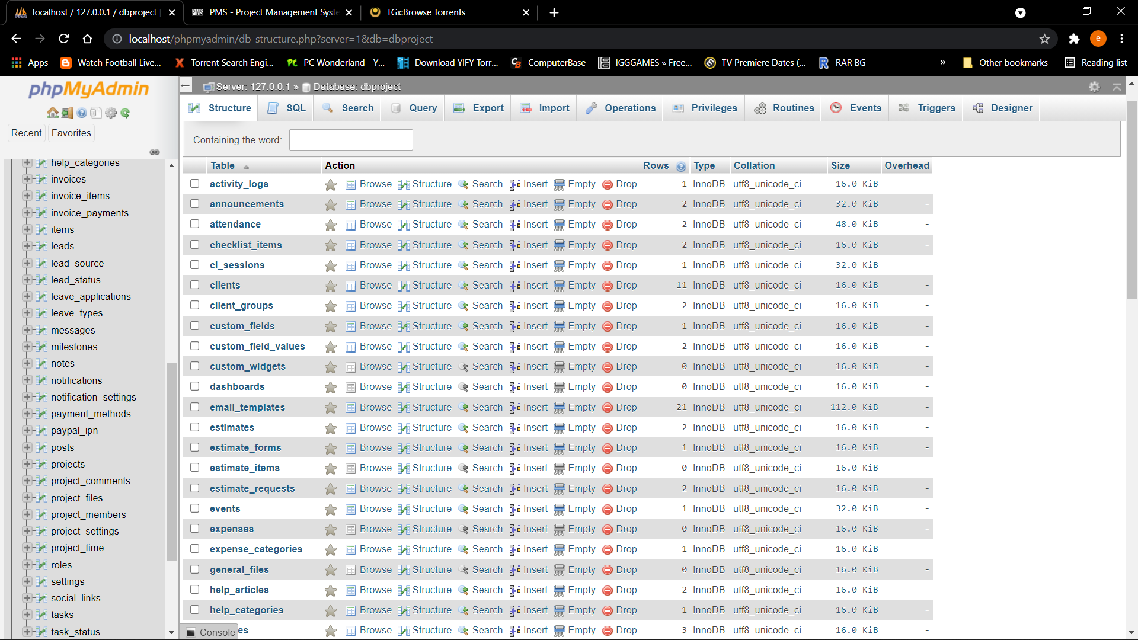

Figure :MySQL Database (Backend)

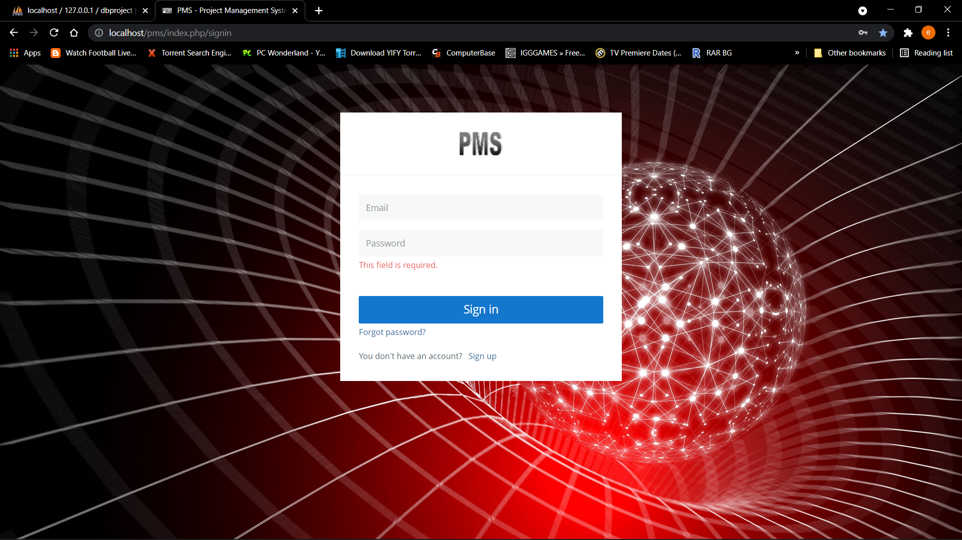

Figure :Login Page

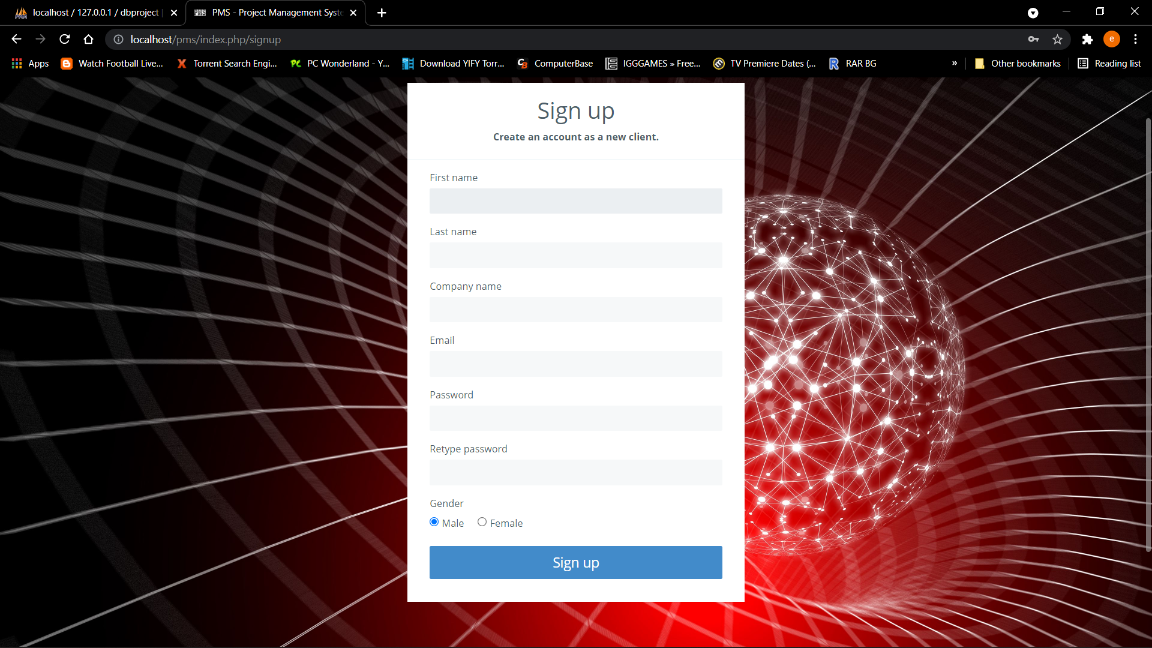

Figure : Sign Up Page

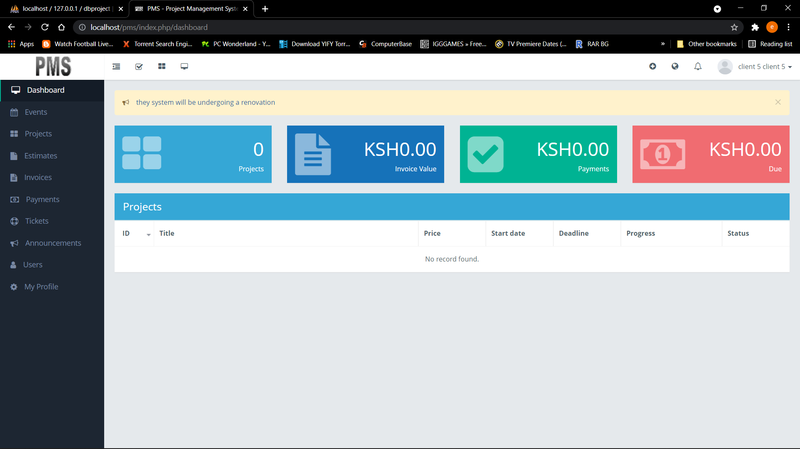

Figure :User Dashboard

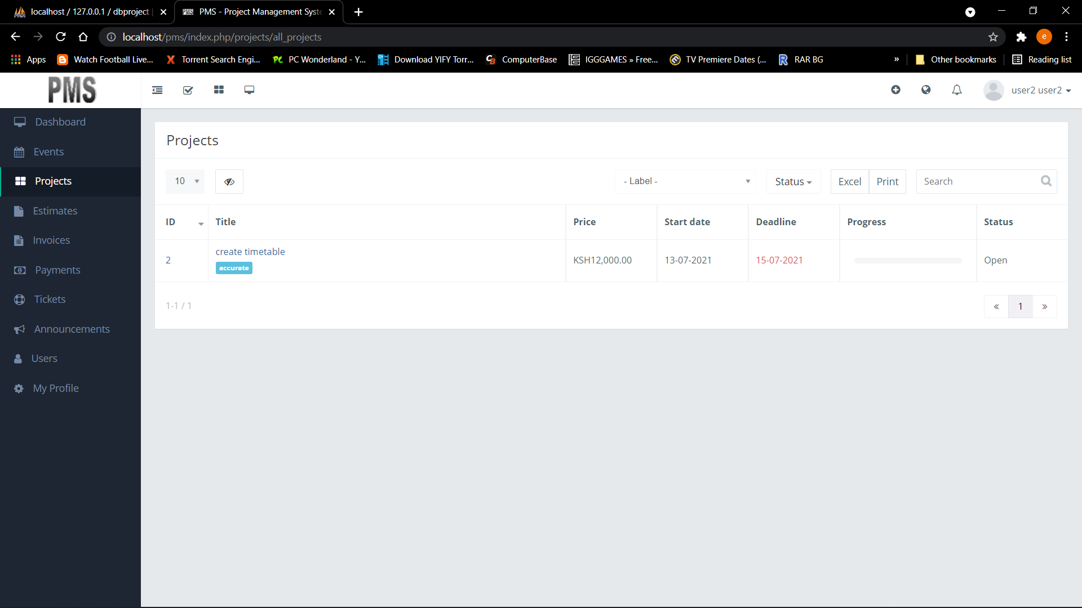

Figure :Project Page

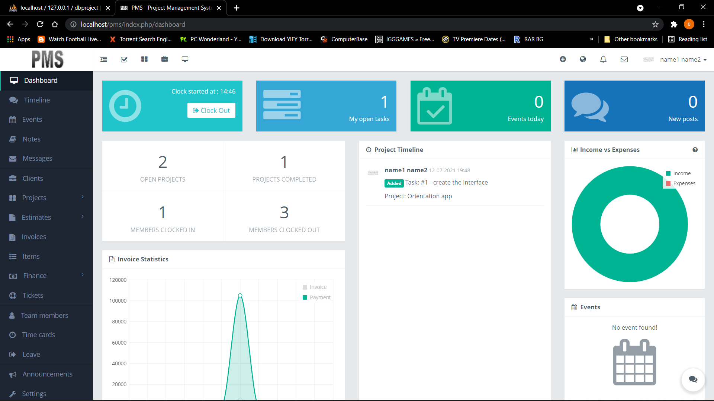

Figure :Admin Dashboard

CONCLUSION

The proposed system meets the requirements needed by the project management stakeholders to solving their projects in real time. The developed system tackles issues with the previous system being ineffective and inefficient in providing adequate and reliable info to users. The system provides a time conservancy means when undertaking projects with faster data retrieval at the same time producing the necessary needs to clients. The whole system has been digitized meaning more opportunities for data processing with the help of the internet, cloud infrastructures that handle data processing in real time. The project has been completed successfully with the maximum satisfaction of the organization. The constraints are met and overcome successfully. The system is designed as like it was decided in the design phase. The project delivers a full-fledged application satisfying the user requirements. The system is very flexible and versatile. This software has a user-friendly screen that enables the user to use without any inconvenience. Validation checks induced have greatly reduced errors. Provisions have been made to upgrade the software. The application has been tested with live data and has provided a successful result. Hence the software has proved to work efficiently.

RECOMMENDATION

The project managers should keep confidential data received from clients (such as the user registration details, payment information) safe and should not avail them to the wrong hands. Disclosing this information should be lawful or by the consent of the persons. Clients should be given sufficient training on the kind of operations they can perform so that the procedures work forward as designated without having to halt the system due to wrong user input. Finally, this system can be modified further in relation to different types of industries and organization sizes to determine its usability even for large enterprises, non-governmental organizations. I therefore recommend that any prospecting project stake holders undertake the adoption of the newly established project management system. The benefits at stake are much better and guarantee better project material and resources utilization within the right deadlines and without any inconveniences.

**REFERENCE**

Bob, H., & Mike, C. (2002). *Software Project Management.* London: McGraw Hill.

ICTer, & IEEE. (2014). Web Based Collaboration, Monitoring and Management System. 109-155.

Kieron, C. (2001). *Software Project management: From concept to deployment.* Scottsdale: Coriolis.

McManus, J., & Wood-harper, T. (2003). *Information system Management: methods, tools and techniques.* Harlow: Prentice Hall.

Nagel, W. (2005). *Subversion version control.* Upper Saddle River (N.J.): Prentice Hall/PTR.

PDEVM. (2017). Fundamentals of Project Management For Development Organizations. *Project Management For Development Organizations*, 13-20.

Roger, S. (2000). *Sofware Engineering.* UK: Pressman.

Shelly, C. (1991). *System Analysis and Design.* Boston: Adamski.

William, N. (2005). *Subversion version control: using the Subversion version control system in development projects.* Upper Saddle River(N.J.): Prentice Hall.

**APPENDICES**

**Appendix 1: Schedule**

**Project Schedule Task**

This duration is based on a full-time consultant and quick turn around on questions from the business unit. This is the fastest possible duration. If a consultant is utilized part time or encounters delayed business unit feedback, the duration could increase to six months.

|  |  |  |  |  |  |  |  |  |  |  |  |  |
| --- | --- | --- | --- | --- | --- | --- | --- | --- | --- | --- | --- | --- |
| **TIME IN WEEKS** | | | | | | | | | | | | |
| **ACTIVITY** | **1** | **2** | **3** | **4** | **5** | **6** | **7** | **8** | **9** | **10** | **11** | **12** |
| Requirement’s elicitation |  |  |  |  |  |  |  |  |  |  |  |  |
| Feasibility Study |  |  |  |  |  |  |  |  |  |  |  |  |
| System Analysis |  |  |  |  |  |  |  |  |  |  |  |  |
| System Design |  |  |  |  |  |  |  |  |  |  |  |  |
| Coding |  |  |  |  |  |  |  |  |  |  |  |  |
| Testing |  |  |  |  |  |  |  |  |  |  |  |  |
| Documentation |  |  |  |  |  |  |  |  |  |  |  |  |
| Implementation |  |  |  |  |  |  |  |  |  |  |  |  |

|  |  |
| --- | --- |
| Database and Screen Design | Duration 5 days |
| Programming Screen Functionality Programming Reports | 8 days 2 days 3 days 3 days |
| Convert data from existing system Testing | 1 week 1 week |
| Backup and Recovery Setup Training | 23 days |
| Total Duration | Duration 5 days |

*Table 1:Project Time Frame*

**Appendix 2: Budget**

The research will be carried out on a budget with particulars stipulated in the table

|  |  |  |
| --- | --- | --- |
| **ITEM** **NUMBER** | **ITEM NAME** | **COST** |
| 1. | Installation Labor | Sh 25000 |
| 2. | Internet Access | Sh 15000 |
| 3. | Literature and Materials | Sh 10000 |
|  | **Total** | Sh **50000** |

*Table 2:Project Budget Estimation*

**Appendix 3: Sample codes**

**Sample backend SQL server configuration source code**

-- phpMyAdmin SQL Dump

-- version 4.8.3

-- https://www.phpmyadmin.net/

-- Host: 127.0.0.1

-- Generation Time: Dec 08, 2019 at 12:19 PM

-- Server version: 10.1.37-MariaDB

-- PHP Version: 7.2.12

SET SQL_MODE = "NO_AUTO_VALUE_ON_ZERO";

SET AUTOCOMMIT = 0;

START TRANSACTION;

SET time_zone = "+00:00";

/*!40101 SET @OLD_CHARACTER_SET_CLIENT=@@CHARACTER_SET_CLIENT */;

/*!40101 SET @OLD_CHARACTER_SET_RESULTS=@@CHARACTER_SET_RESULTS */;

/*!40101 SET @OLD_COLLATION_CONNECTION=@@COLLATION_CONNECTION */;

/*!40101 SET NAMES utf8mb4 */;

-- Database: `dbproject`

-- Table structure for table `activity_logs`

CREATE TABLE `activity_logs` (

  `id` int(11) NOT NULL,

  `created_at` datetime NOT NULL,

  `created_by` int(11) NOT NULL,

  `action` enum('created','updated','deleted') COLLATE utf8_unicode_ci NOT NULL,

  `log_type` varchar(30) COLLATE utf8_unicode_ci NOT NULL,

  `log_type_title` mediumtext COLLATE utf8_unicode_ci NOT NULL,

  `log_type_id` int(11) NOT NULL DEFAULT '0',

  `changes` mediumtext COLLATE utf8_unicode_ci,

  `log_for` varchar(30) COLLATE utf8_unicode_ci NOT NULL DEFAULT '0',

  `log_for_id` int(11) NOT NULL DEFAULT '0',

  `log_for2` varchar(30) COLLATE utf8_unicode_ci DEFAULT NULL,

  `log_for_id2` int(11) DEFAULT NULL,

  `deleted` tinyint(1) NOT NULL DEFAULT '0'

) ENGINE=InnoDB DEFAULT CHARSET=utf8 COLLATE=utf8_unicode_ci;

-- Table structure for table `announcements`

CREATE TABLE `announcements` (

  `id` int(11) NOT NULL,

  `title` text COLLATE utf8_unicode_ci NOT NULL,

  `description` mediumtext COLLATE utf8_unicode_ci NOT NULL,

  `start_date` date NOT NULL,

  `end_date` date NOT NULL,

  `created_by` int(11) NOT NULL,

  `share_with` mediumtext COLLATE utf8_unicode_ci,

  `created_at` datetime NOT NULL,

  `files` text COLLATE utf8_unicode_ci NOT NULL,

  `read_by` mediumtext COLLATE utf8_unicode_ci,

  `deleted` int(1) NOT NULL DEFAULT '0'

) ENGINE=InnoDB DEFAULT CHARSET=utf8 COLLATE=utf8_unicode_ci;

-- Table structure for table `attendance`

CREATE TABLE `attendance` (

  `id` int(11) NOT NULL,

  `status` enum('incomplete','pending','approved','rejected','deleted') COLLATE utf8_unicode_ci NOT NULL DEFAULT 'incomplete',

  `user_id` int(11) NOT NULL,

  `in_time` datetime NOT NULL,

  `out_time` datetime DEFAULT NULL,

  `checked_by` int(11) DEFAULT NULL,

  `note` text COLLATE utf8_unicode_ci,

  `checked_at` datetime DEFAULT NULL,

  `reject_reason` text COLLATE utf8_unicode_ci,

  `deleted` int(1) NOT NULL DEFAULT '0'

) ENGINE=InnoDB DEFAULT CHARSET=utf8 COLLATE=utf8_unicode_ci;

-- Table structure for table `checklist_items`

CREATE TABLE `checklist_items` (

  `id` int(11) NOT NULL,

  `title` text COLLATE utf8_unicode_ci NOT NULL,

  `is_checked` int(11) NOT NULL DEFAULT '0',

  `task_id` int(11) NOT NULL DEFAULT '0',

  `sort` int(11) NOT NULL DEFAULT '0',

  `deleted` int(11) NOT NULL DEFAULT '0'

) ENGINE=InnoDB DEFAULT CHARSET=utf8 COLLATE=utf8_unicode_ci;

-- Table structure for table `ci_sessions`

CREATE TABLE `ci_sessions` (

  `id` varchar(128) COLLATE utf8_unicode_ci NOT NULL,

  `ip_address` varchar(45) COLLATE utf8_unicode_ci NOT NULL,

  `timestamp` int(10) UNSIGNED NOT NULL DEFAULT '0',

  `data` blob NOT NULL

) ENGINE=InnoDB DEFAULT CHARSET=utf8 COLLATE=utf8_unicode_ci;

-- Dumping data for table `ci_sessions`

INSERT INTO `ci_sessions` (`id`, `ip_address`, `timestamp`, `data`) VALUES

('3fvgpd87f0rptf9qci08b5gtbcq0fb34', '::1', 1575803959, 0x5f5f63695f6c6173745f726567656e65726174657c693a313537353830333933313b757365725f69647c733a313a2231223b)

-- Table structure for table `clients`

CREATE TABLE `clients` (

  `id` int(11) NOT NULL,

  `company_name` varchar(150) COLLATE utf8_unicode_ci NOT NULL,

  `address` text COLLATE utf8_unicode_ci,

  `city` varchar(50) COLLATE utf8_unicode_ci DEFAULT NULL,

  `state` varchar(50) COLLATE utf8_unicode_ci DEFAULT NULL,

  `zip` varchar(50) COLLATE utf8_unicode_ci DEFAULT NULL,

  `country` varchar(50) COLLATE utf8_unicode_ci DEFAULT NULL,

  `created_date` date NOT NULL,

  `website` text COLLATE utf8_unicode_ci,

  `phone` varchar(20) COLLATE utf8_unicode_ci DEFAULT NULL,

  `currency_symbol` varchar(20) COLLATE utf8_unicode_ci DEFAULT NULL,

  `starred_by` mediumtext COLLATE utf8_unicode_ci NOT NULL,

  `group_ids` text COLLATE utf8_unicode_ci NOT NULL,

  `deleted` tinyint(1) NOT NULL DEFAULT '0',

  `is_lead` tinyint(1) NOT NULL DEFAULT '0',

  `lead_status_id` int(11) NOT NULL,

  `owner_id` int(11) NOT NULL,

  `sort` int(11) NOT NULL DEFAULT '0',

  `lead_source_id` int(11) NOT NULL,

  `last_lead_status` text COLLATE utf8_unicode_ci NOT NULL,

  `client_migration_date` date NOT NULL,

  `vat_number` text COLLATE utf8_unicode_ci,

  `currency` varchar(3) COLLATE utf8_unicode_ci DEFAULT NULL,

  `disable_online_payment` tinyint(1) NOT NULL DEFAULT '0'

) ENGINE=InnoDB DEFAULT CHARSET=utf8 COLLATE=utf8_unicode_ci;

**Dashboard models**

<?php

class Dashboards_model extends Crud_model {

    private $table = null;

    function __construct() {

        $this->table = 'dashboards';

        parent::__construct($this->table);

    }

    function get_details($options = array()) {

        $dashboard_table = $this->db->dbprefix("dashboards");

        $where = "";

        $user_id = get_array_value($options, "user_id");

        if ($user_id) {

            $where .= " AND $dashboard_table.user_id=$user_id";

        }

        $id = get_array_value($options, "id");

        if ($id) {

            $where .= " AND $dashboard_table.id= $id";

        }

        $sql = "SELECT $dashboard_table.*, IF($dashboard_table.sort!=0, $dashboard_table.sort, $dashboard_table.id) AS new_sort

        FROM $dashboard_table

        WHERE $dashboard_table.deleted=0 $where

        ORDER BY new_sort DESC";

        return $this->db->query($sql);

    }

}

**Project settings model**

<?php

class Project_settings_model extends Crud_model {

    private $table = null;

    function __construct() {

        $this->table = 'project_settings';

        parent::__construct($this->table);

    }

    function get_setting($project_id, $setting_name) {

        $result = $this->db->get_where($this->table, array('project_id' => $project_id, 'setting_name' => $setting_name), 1);

        if ($result->num_rows() == 1) {

            return $result->row()->setting_value;

        }

    }

    function save_setting($project_id, $setting_name, $setting_value) {

        $fields = array(

            'project_id' => $project_id,

            'setting_name' => $setting_name,

            'setting_value' => $setting_value

        );

        $exists = $this->get_setting($project_id, $setting_name);

        if ($exists === NULL) {

            return $this->db->insert($this->table, $fields);

        } else {

            $this->db->where('setting_name', $setting_name);

            $this->db->where('project_id', $project_id);

            $this->db->update($this->table, $fields);

        }

    }

}

**Roles model**

<?php

class Roles_model extends Crud_model {

    private $table = null;

    function __construct() {

        $this->table = 'roles';

        parent::__construct($this->table);

    }

    function get_details($options = array()) {

        $roles_table = $this->db->dbprefix('roles');

        $where= "";

        $id=get_array_value($options, "id");

        if($id){

            $where =" AND $roles_table.id=$id";

        }

        $sql = "SELECT $roles_table.*

        FROM $roles_table

        WHERE $roles_table.deleted=0 $where";

        return $this->db->query($sql);

    }